Homework 10. Learn About Robotics

Complete at least one of the courses from the RobotIgnite academy . The free courses can be found under the Learning Paths here:

https://www.robotigniteacademy.com/en/catalog/path/

The course you choose depends on your interest in robotics; if you’re uncertain, select one of the courses under the “Ros for Beginners” path.

Paste in a screen capture below showing that you completed the course.

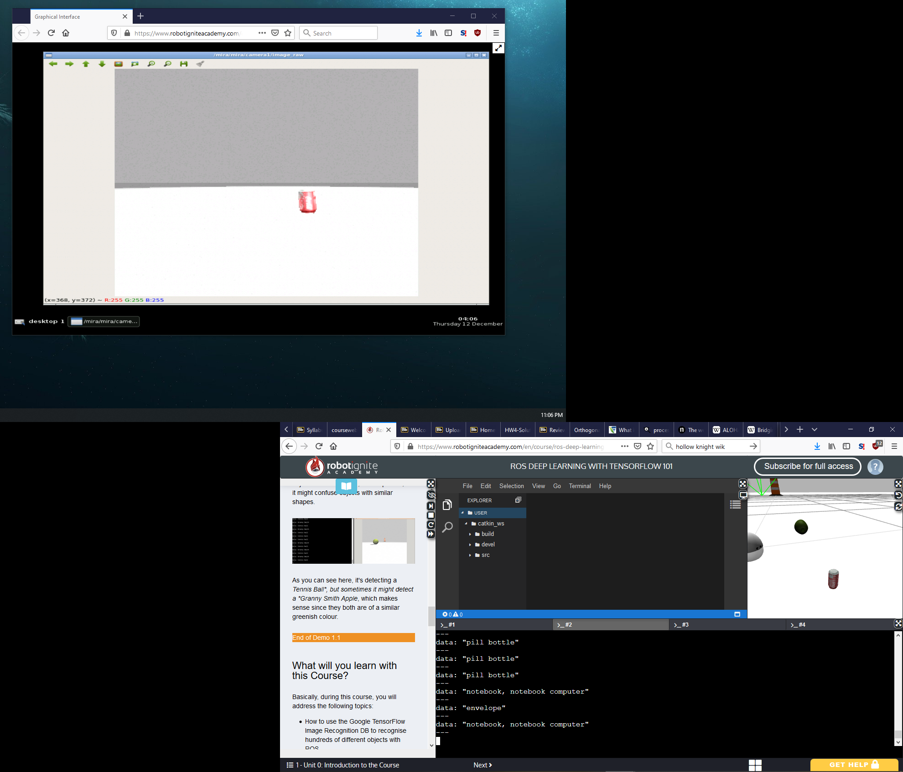

Briefly describe security concerns that should be taken into account in robot design and coding that were not covered in the course.

Very little was covered in the course concerning security. Off the top of my head, the physical security for a robot is important, especially if it’s supposed to operate around people that might want to access and rewire it (for example, the Starship drones delivering food on campus). If there are ports exposed, maybe you could drill a hole through the top and bottom and put a small padlock on it.

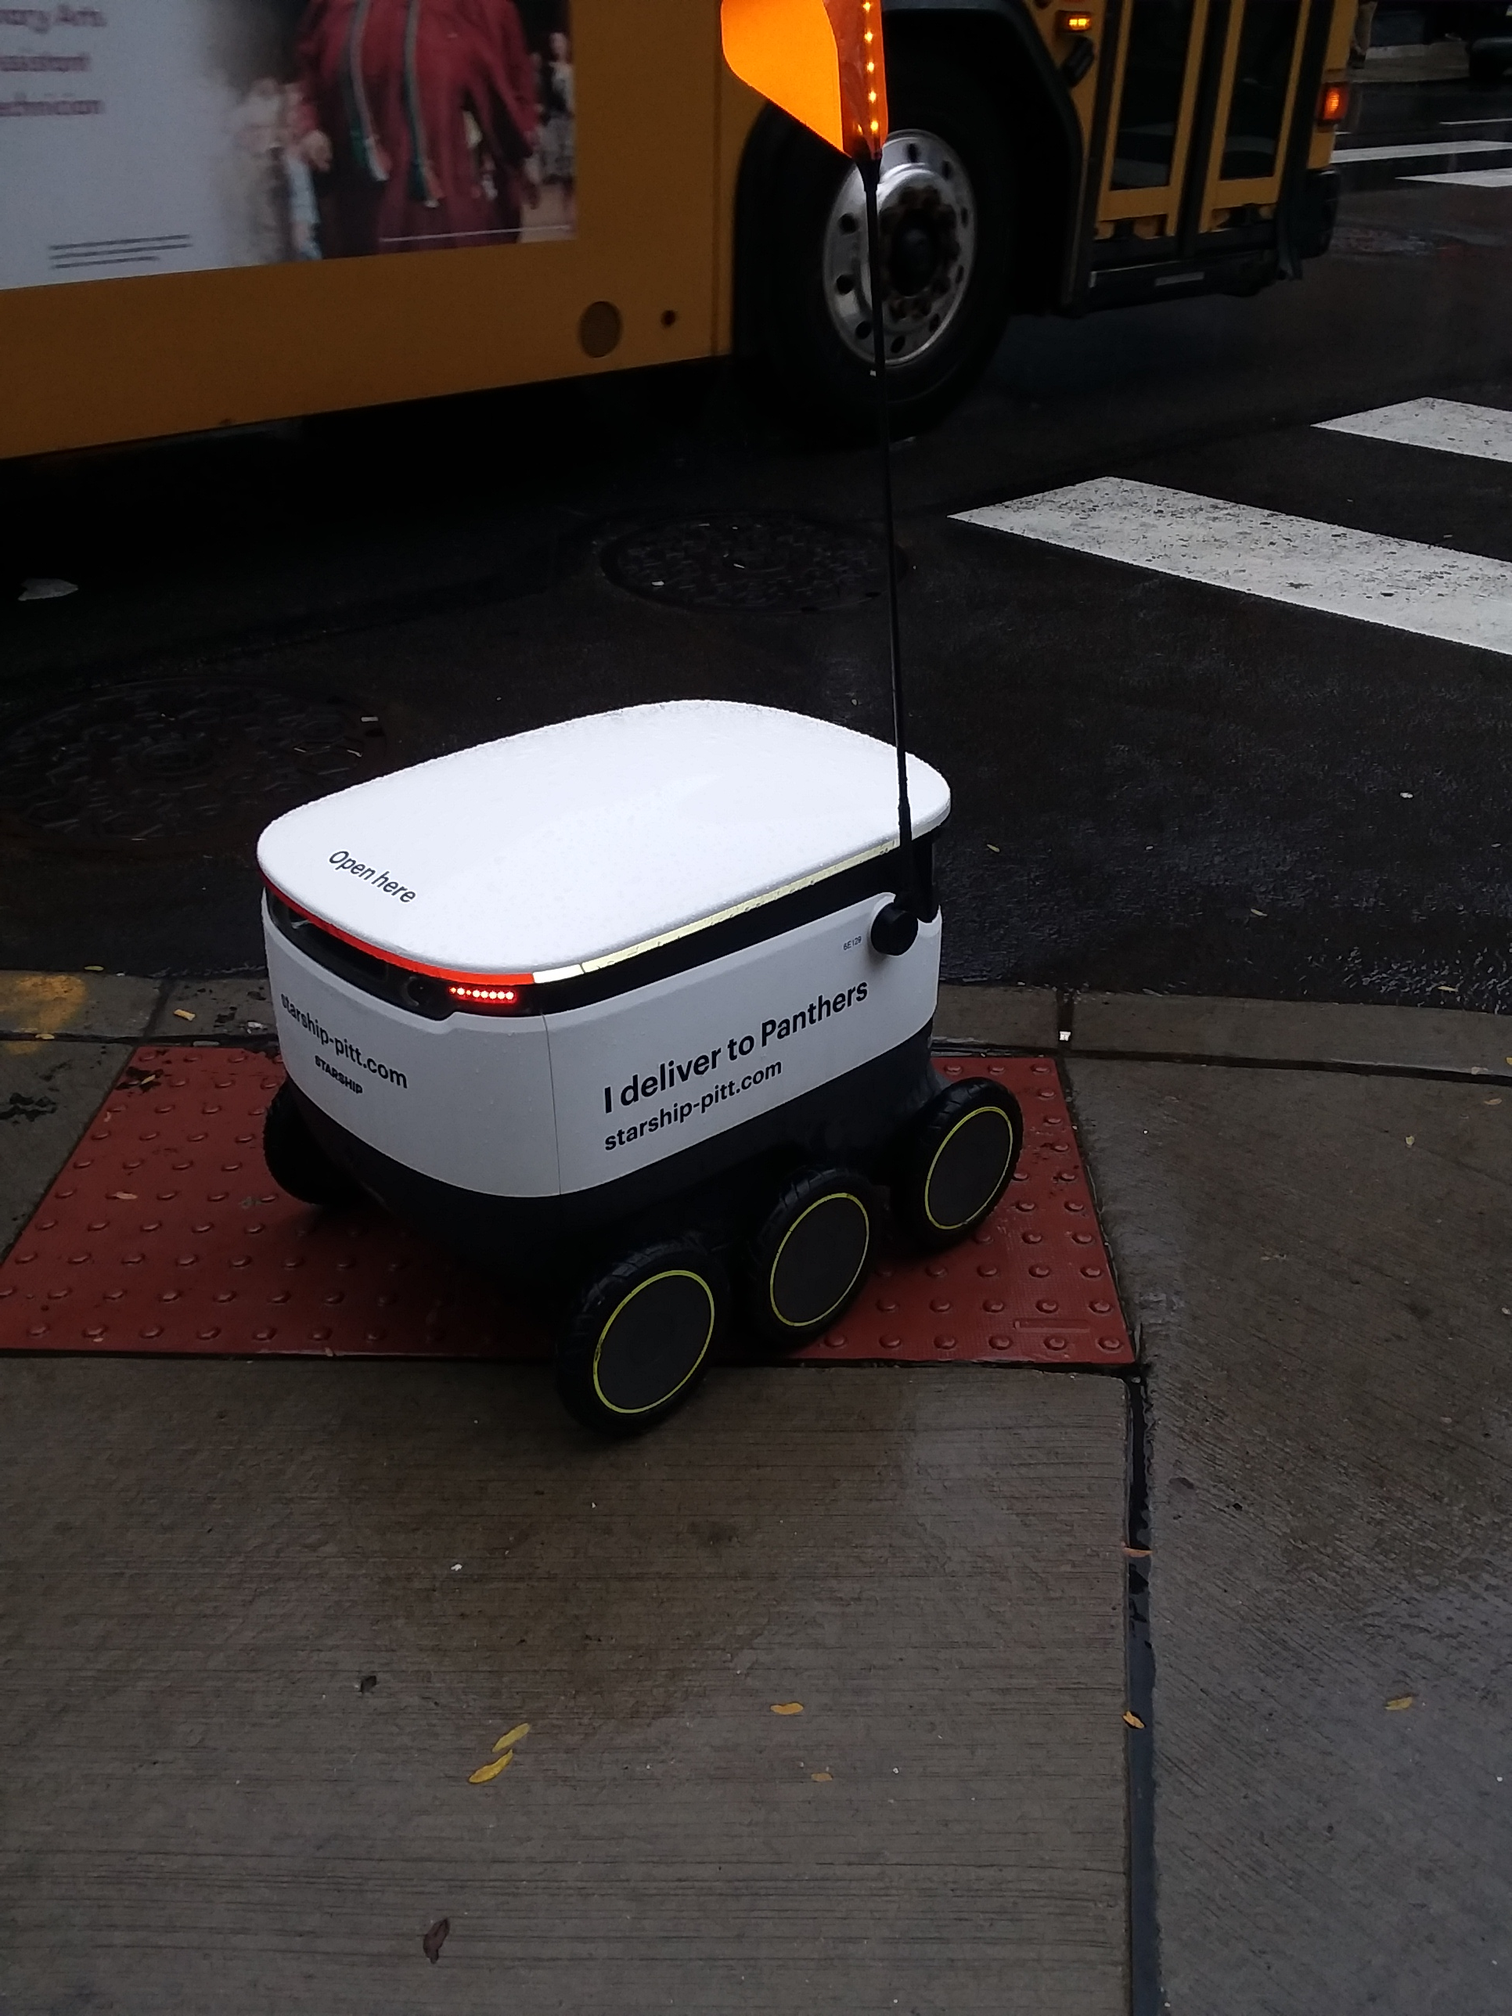

I took a picture of one of the
drones the first time I saw one

