Homework 2. Writing and running a C program
Alexander Pickering
In this lab you will run a “hello, world” program and you will create a simple C program that will proper case a word. Each program has many possible solutions, the only important thing is to meet (or exceed) the objectives.
This work should be done in your Kali virtual machine.

- Write a C program that prints out the text of your choosing to standard output. You should be able to start with a sample program.
  - Compile the program with gcc (Gnu C Compiler)
  - Run the program
Paste a screen shot of your code
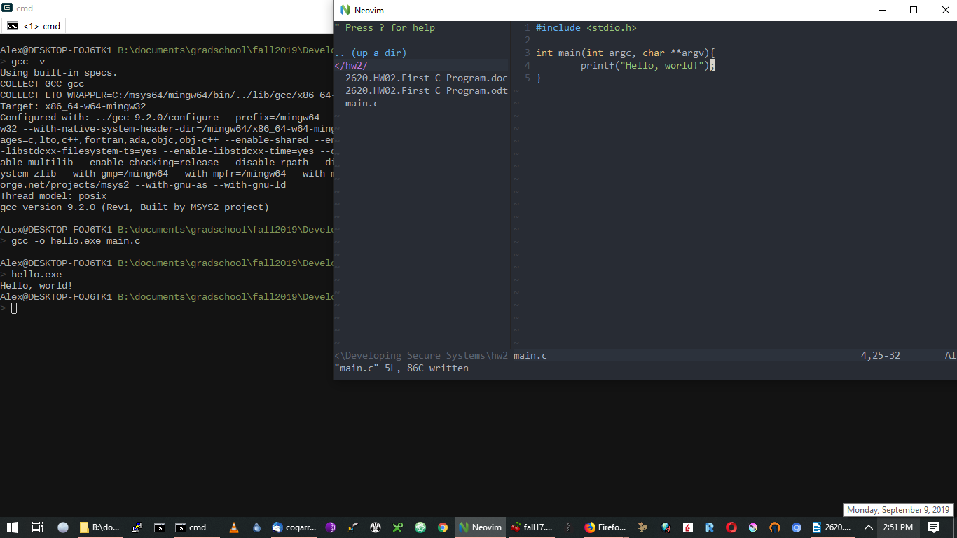
Paste a screen shot of your program running successfully
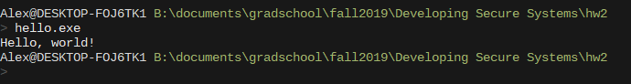
- Write a program that accepts an input and prints the input to standard output.
Paste a screen shot of your code
Paste a screen shot of your program running successfully
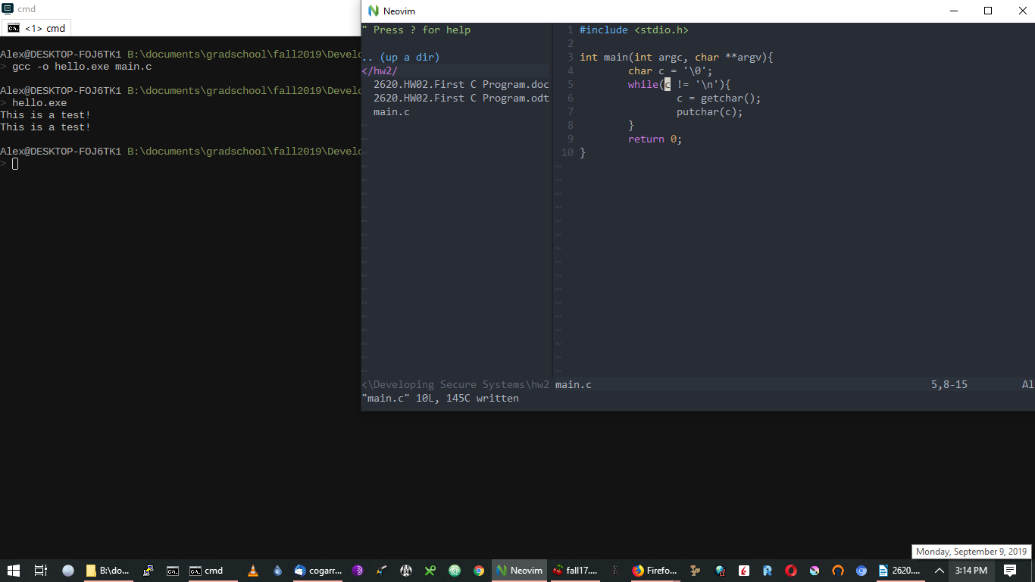
- Update the program you wrote in #2 above to convert the first character of text to upper case before printing the output. Do this using bit math to set the correct bit in the first character of your input.
Paste a screen shot of your code
Paste a screen shot of your program running successfully
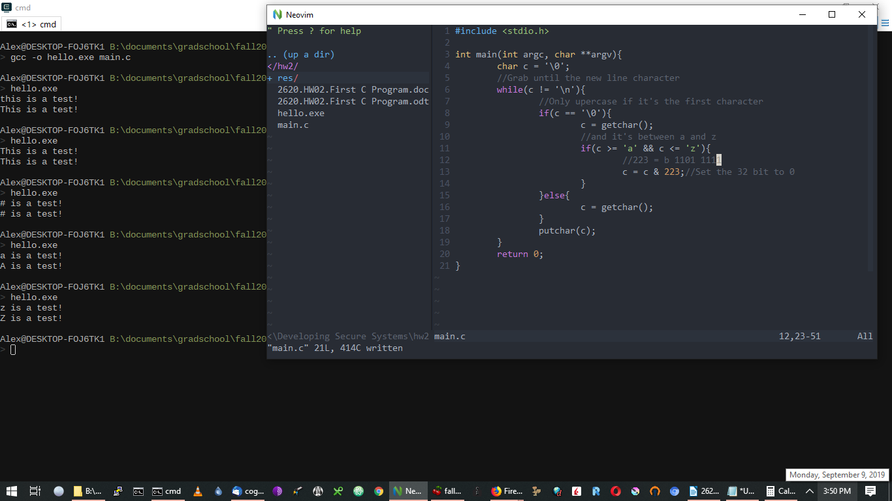
- Add a feature of your choosing to this program. Some possibilities might include:
  - Improved error handling
  - Additional output formatting
  - Debugging features
  - Command-line parameters
  - The ability to work on stdin (e.g., echo “hello world” | a.out)

Paste one or more screen shots of your added functionality and briefly describe
It draws Professor Faber saying the string you give it.


