Homework 3. Data Structures
Alex Pickering
In this lab you will write code to take in a sentence structure, convert it to an array of words, and proper case each word in the sentence. This work should be done in your Kali virtual machine.

- Write a function to return accept a string input using the following function prototype:
void getString (char *in, int buffer);
void getString(char *in, int buffer){
char *c = in;
for(; c < in + buffer; c++){
*c = getchar();
if(*c == EOF)
break;
}
*c = '\0';
}
- Write a function that accepts a single string and splits the string into an array of words and returns the number of words found using the following function prototype:
int string2array (char *inString, char **wordarray);
int string2array(char *inString, char **wordarray){
const char whitespace[] = " ";
char **cursor = wordarray;
int ret = 0;
char *this = NULL;
while(1){
this = strtok(inString,whitespace);
if(this == NULL)
break;
char *dest = strcpy(wordarray[ret],this);
inString = NULL;
ret++;
}
return ret;
}
- Write a function to proper case a string using the following function prototype:
void proper (char *word);
void proper(char *word){
word[0] = toupper(word[0]);
}
- Write a function to print out strings stored in an array using the following function prototype:
void printArray (char **words, int wordcount);
void printArray(char **words, int wordcount){
for(int i = 0; i < wordcount; i++)
printf("%s\n",words[i]);
}
- Put it all together using the following structure:
struct Sentence {
char string[50];
char *words[10];
int wordCount = -1;
};
  - Store input into the sentence string,
  - Parse the string into an array of words and store the number of words found,
  - Proper case each word in the sentence,
  - and print out the proper cased sentence

Paste a screen shot that shows your code running successfully.
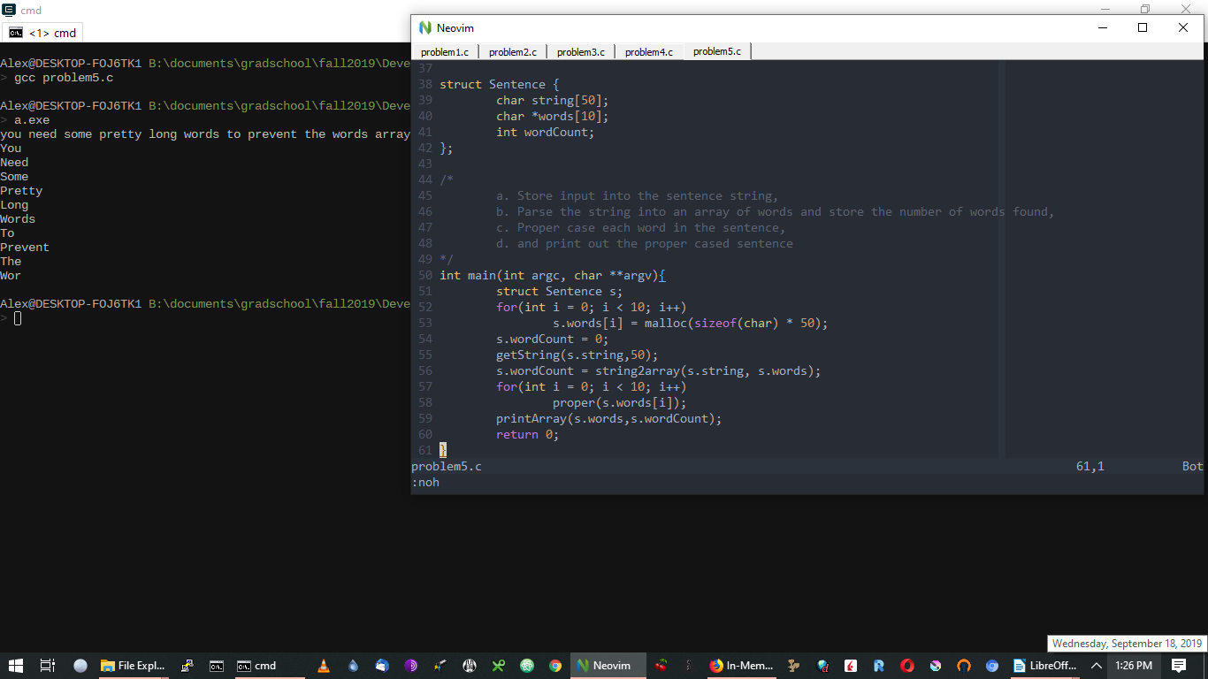
Upload your code with your assignment or paste it in below.

