Homework 6. APIs

In this lab you will create a microservice API written in Python. The service will accept a sentence and return a sorted, proper case list of words in the sentence. The API will be written in Flask, https://flask.palletsprojects.com

- Verify that Flask is installed on your Kali virtual machine. See the instructions under “Installation” at the Flask web site. For our purposes you can skip the virtual environment and type
$ pip install Flask

- Run a Flask “Hello, world” application. Follow the “Quickstart” documentation on the Flask web site.
Paste two screen captures: one that shows your flask application running, and another that shows a web browser displaying the text from your flask application.
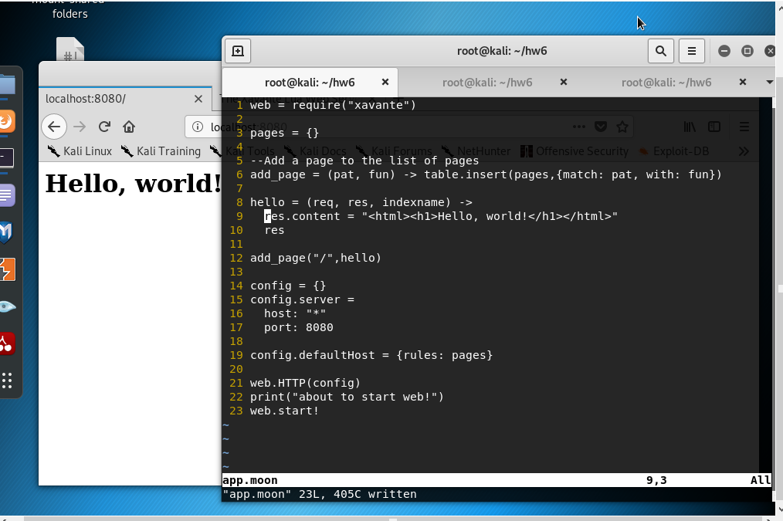
- Import the python code from your last assignment

- Using the code below to get started, write a program that returns a JSON formatted, sorted, proper-cased list of words from a sentence input.

from flask import Flask
from flask import request
import json

app = Flask (__name__)

@app.route('/hi')
def hello_world():
return 'Hello, World!'

@app.route('/proper')
def proper():
# your code starts here

Your final result should look something like the following:

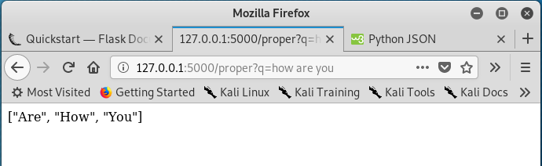

Paste a screen shot that shows your code running successfully.
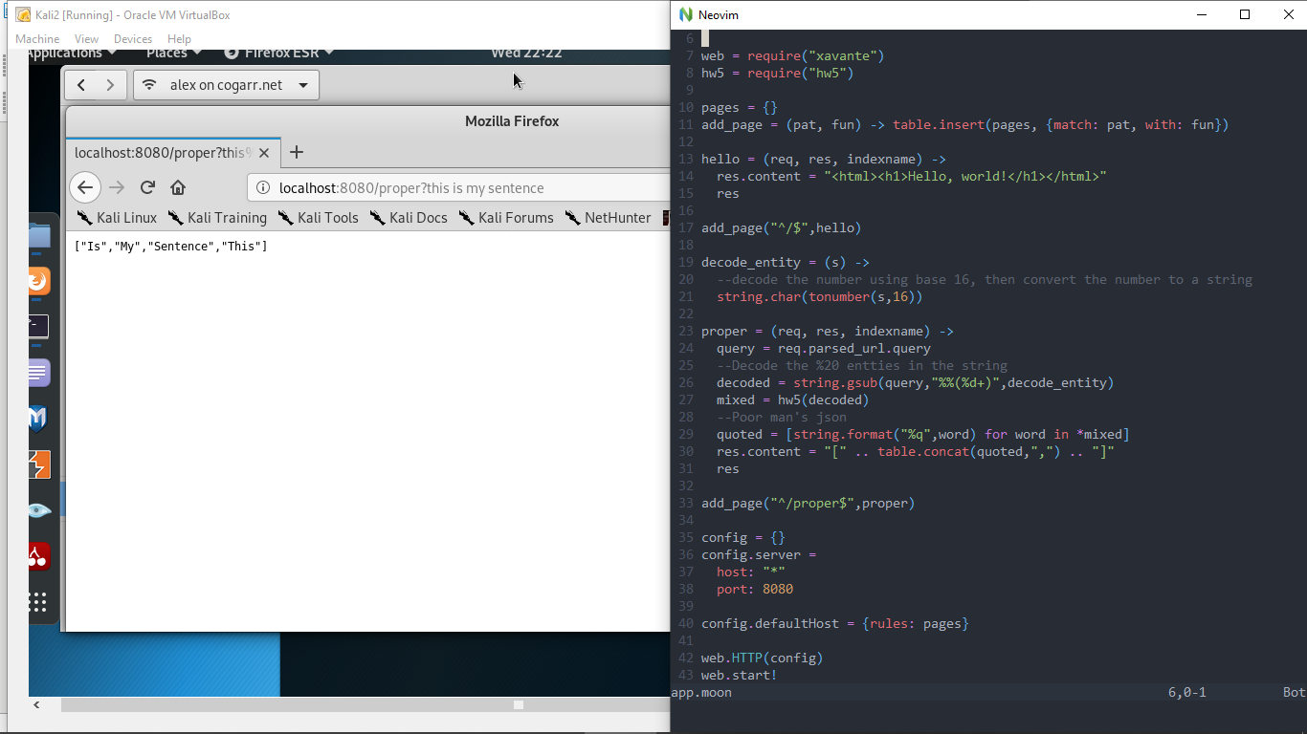
Upload your code with your assignment or paste it in below.

