Homework 7. Hack.Me Web Security

In this lab you will hack a web server.

- Create an account on www.hack.me. Make sure this is a unique account and do not reuse any of your passwords.

- Click Start a hackme
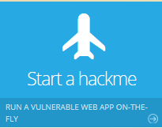
- Search for Mutillidae; then click the name “Mutillidae”
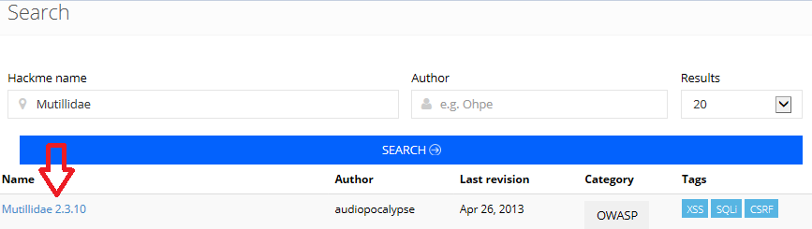
- Click start

- Agree to the terms of service
- You now have your own subdomain
Record your hackme web server below (it should be similar to http://sNNNN-NNNN-NNN-xxx.yyyyy.hack.me/index.php)
http://s117238-101163-ac1.croto.hack.me/index.php
- Choose the following
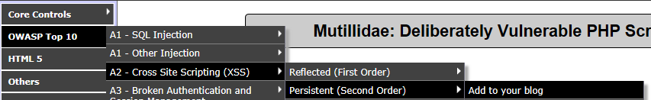
- In the Blog entry enter the following below and click save:
<script>alert("XSS");</script>
Paste a screen capture of your exploit
I couldn’t get it to work with plain xss (I think the university firewall was blocking it), but I could get some of the suggestions from https://www.owasp.org/index.php/XSS_Filter_Evasion_Cheat_Sheet to work.

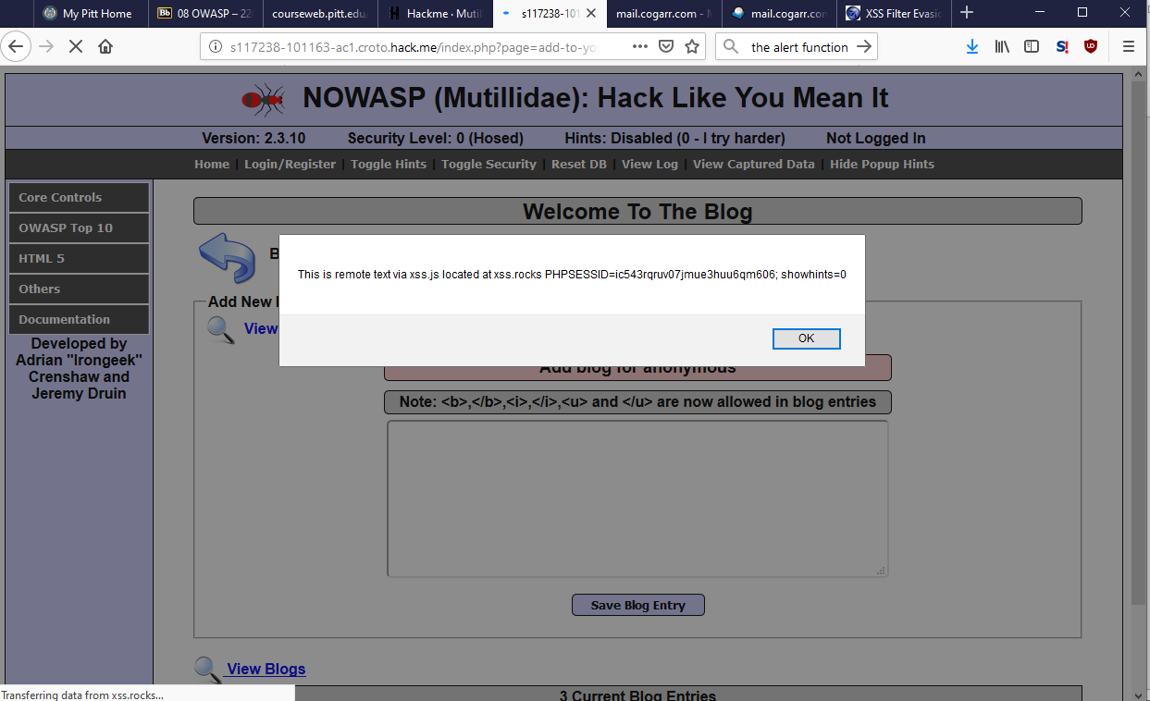

- Complete TWO different types of cross site scripting exploit that shows your session cookie

Describe your exploit and include screen captures

1
Oswap Top 10 > XSS > reflected > Pen Test Tool Lookup
First, I used the on-screen hints to realize that part of the client-supplied headers were returned wholesale in some of the javascript
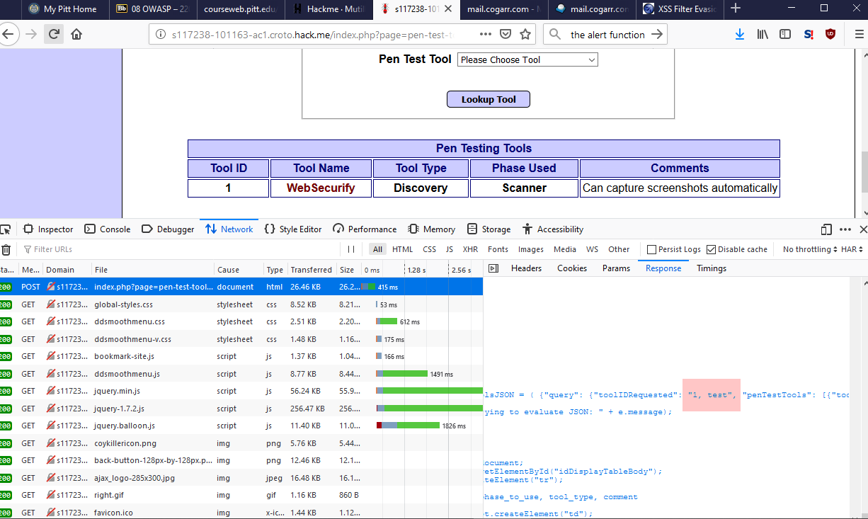
Then, after playing around with url-encoded strings, I got an xss vulnerability:
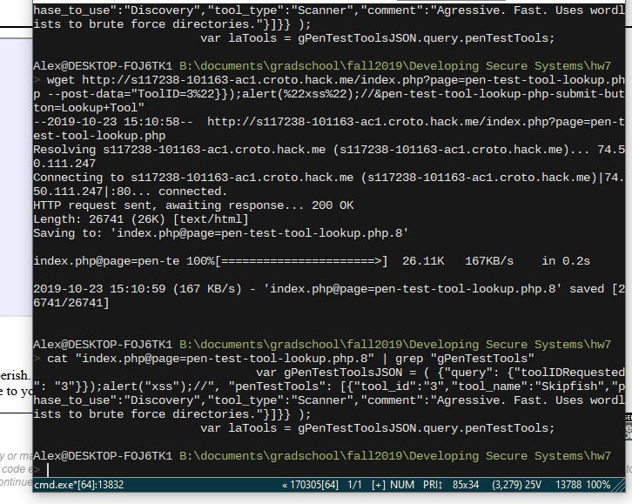
Finally, I showed the user’s cookie on screen with document[“cookie”]
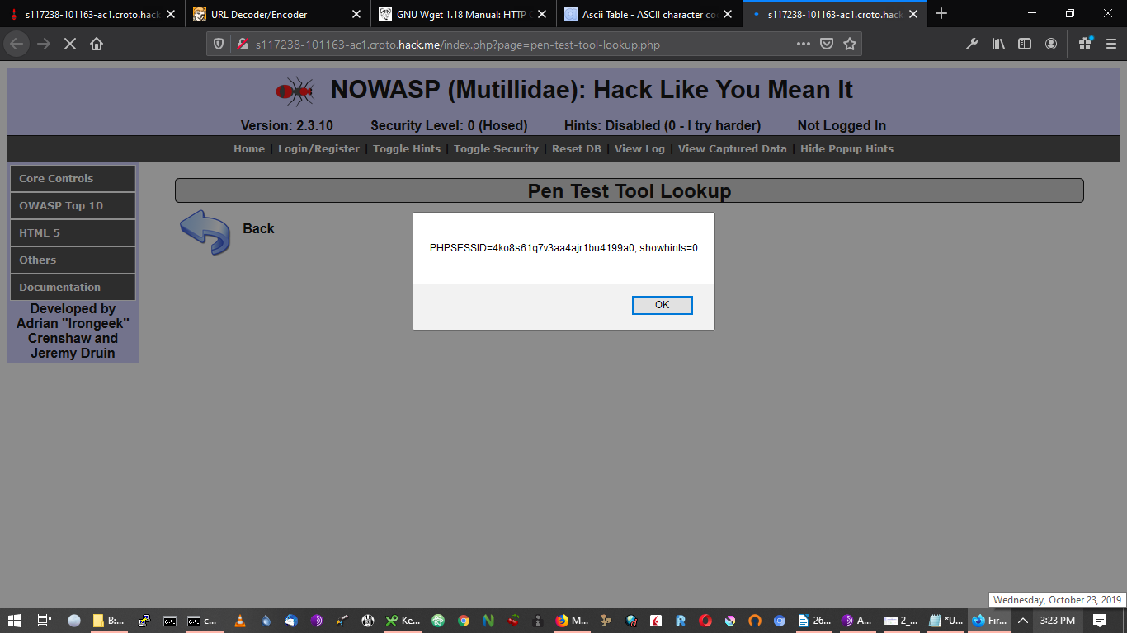
The full post body I used:
ToolID=3%22}});alert(document[%22cookie%22]);//&pen-test-tool-lookup-php-submit-button=Lookup+Tool

2
OSWAP top 10 > XSS > Via HTTP Headers > Show Log
I used the on-screen hints to realize the user-agent area copied data sent by the client in the user agent.
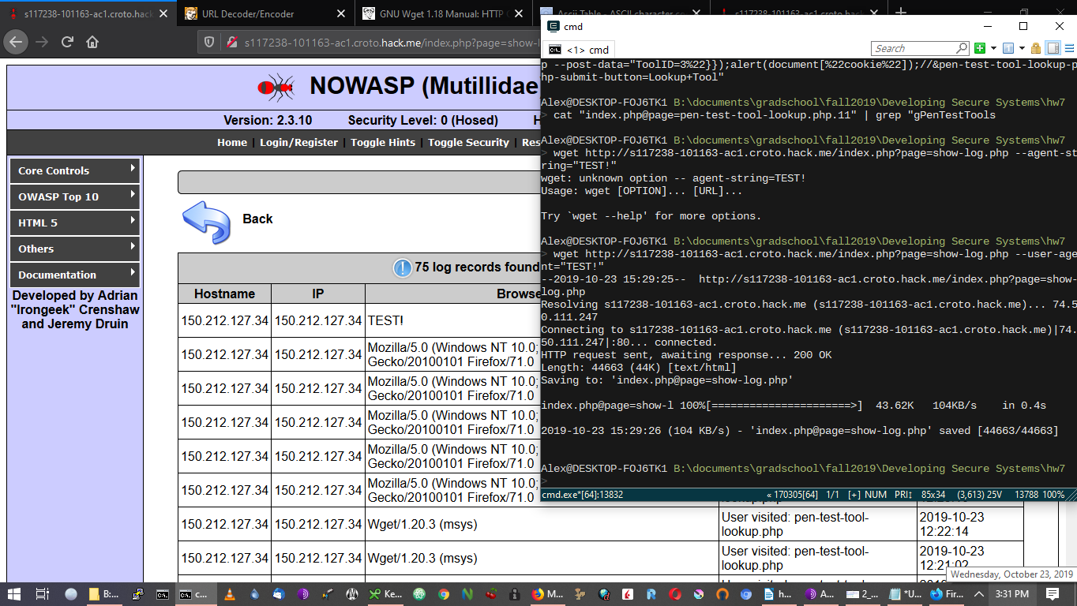
Then I used this to see if I could include arbitrary html in the field (e.g. <b>test</b>); I could.
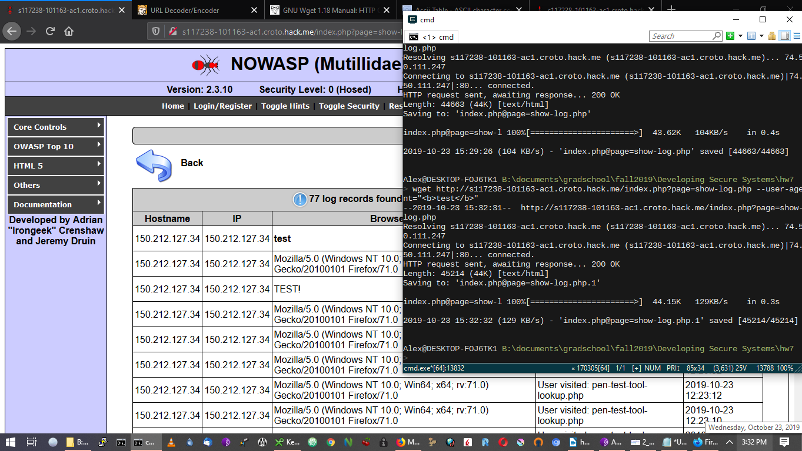
Then I used injected javascript to show the user’s cookie with console.log()
