Homework 9. Configuration Scanning
Alexander Pickering (amp215@pitt.edu)

Use the attached CIS package to scan a machine to determine what configuration settings should be updated to make the machine compliant with the CIS benchmark.
The CIS Assessment Tool is available to you because the University of Pittsburgh is a member of CIS. If you choose to use the tool for any purposes other than for this assignment, register with CIS to download an updated copy of the tool and be sure to follow the licensing/usage restrictions.
Important notes about this assignment:
- You can scan your local workstation, a virtual machine, or a remote device
- You MUST run an authenticated scan. This means you will need to give the scanner administrative/root credentials in order for it to complete.
- Be sure to select the right template to use for the scan
Submit the following:
- An HTML version of the scan results. The results should look something like this:
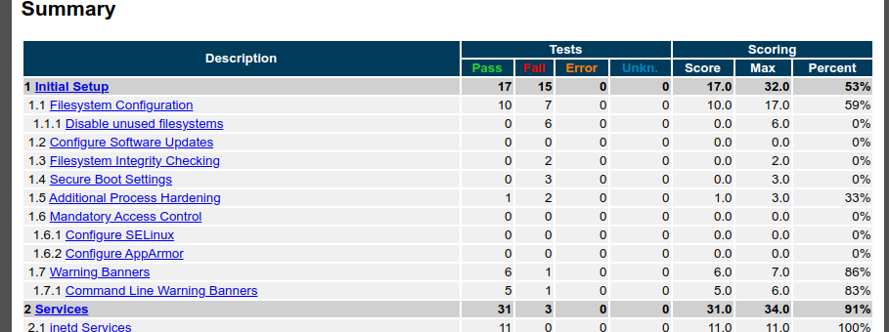
- A paragraph describing at least TWO settings that you feel should be applied to the device you scanned (i.e., true positives)

I get the distinct impression I shouldn’t give out vulnerability scans to people, especially for an online, internet connected server; but oh well.

I could disable the various file systems I’m not using, such as FAT, squashfs, ect. This server is provisioned on Amazon’s cloud and I or anyone else won’t be attaching other file systems. In addition, the server functions only as a mail server and not a general-purpose linux server, so there is no reason to have a telnet client installed or available.

- A paragraph explaining how at least ONE setting does not apply to your device and should not follow the recommended value.
As the hostname might imply, mail.cogarr.com is my email server; I will not disable the IMAP or POP3 servers since that will make the server unable to send or receive email. I can understand why attackers might want to use my email server to send out spam email, but as long as the login system works, I’m not worried about my server being (mis)used like this.

